**CSE3506 – ESSENTIALS OF DATA ANALYTICS**

**EXPT NO: 4**

**DATE:** 24/2/2021

**NAME:** R. Harini

**REG. NO.:** 18BCE1010

**ANOVA**

**AIM**

To perform ANOVA on CreditWorthiness.csv

**MATLAB PROGRAM**

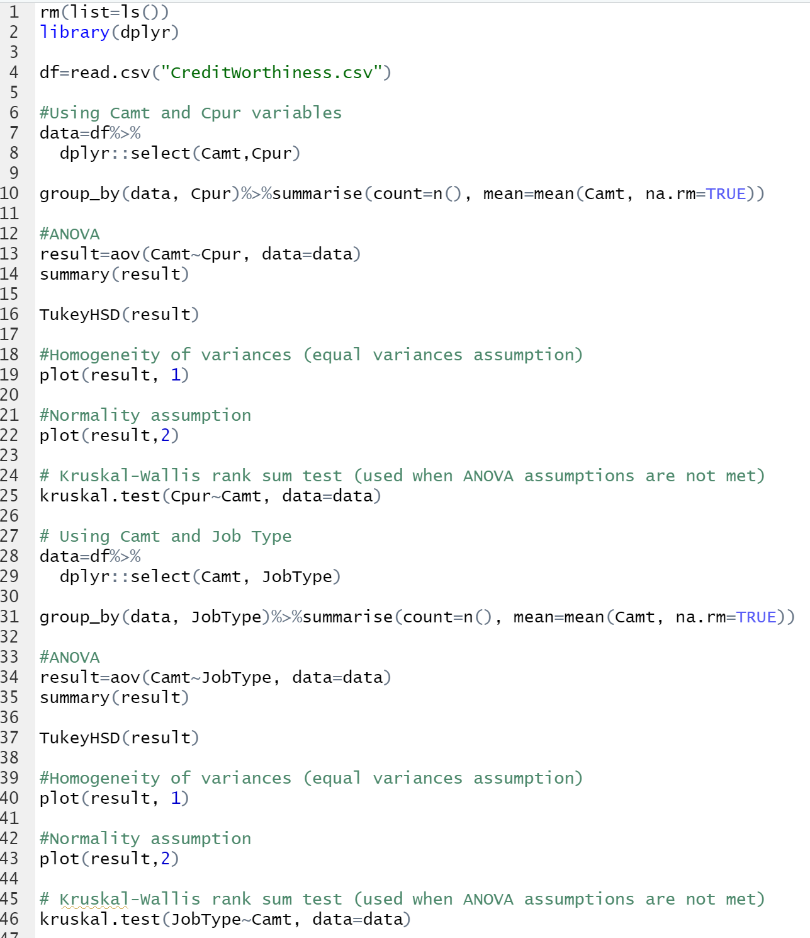

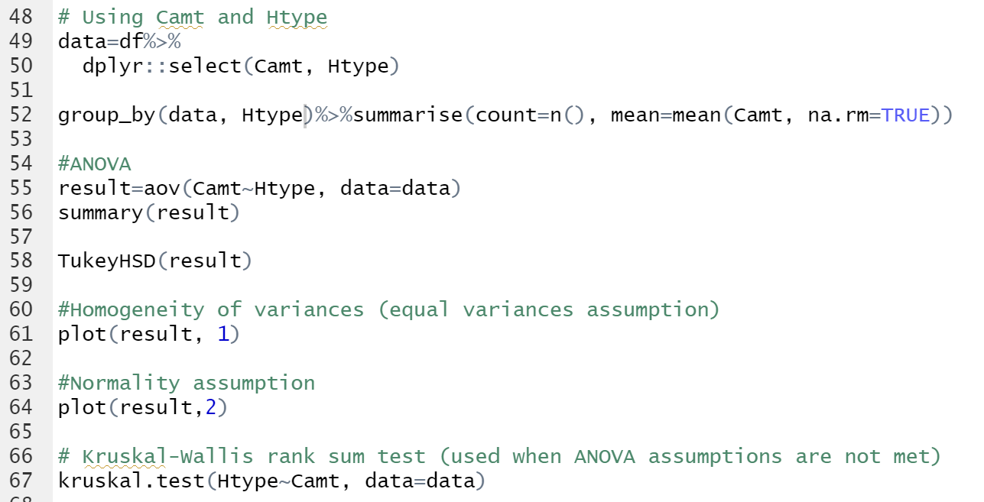

**OUTPUT**

1. **Using Camt and Cpur**

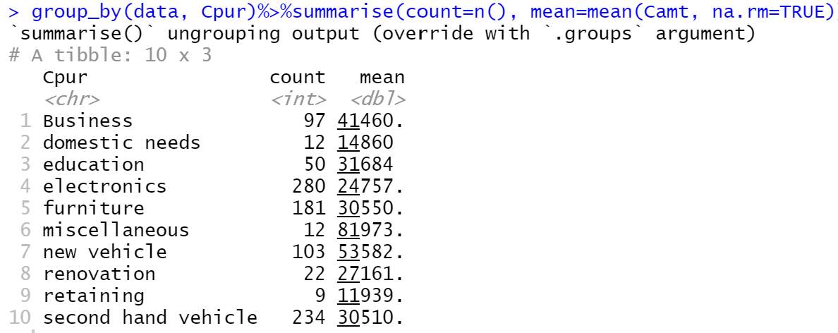

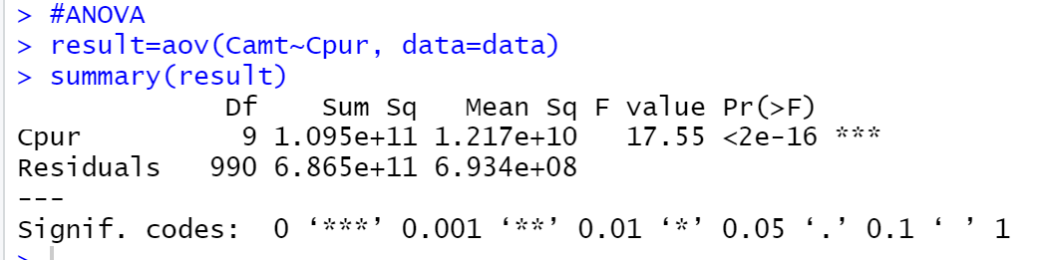

**Due to low F value, the mean of the groups is significantly different.**

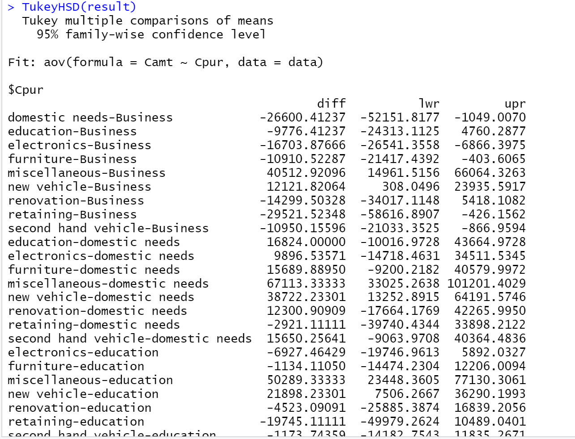

**Homogeneity of Variance**

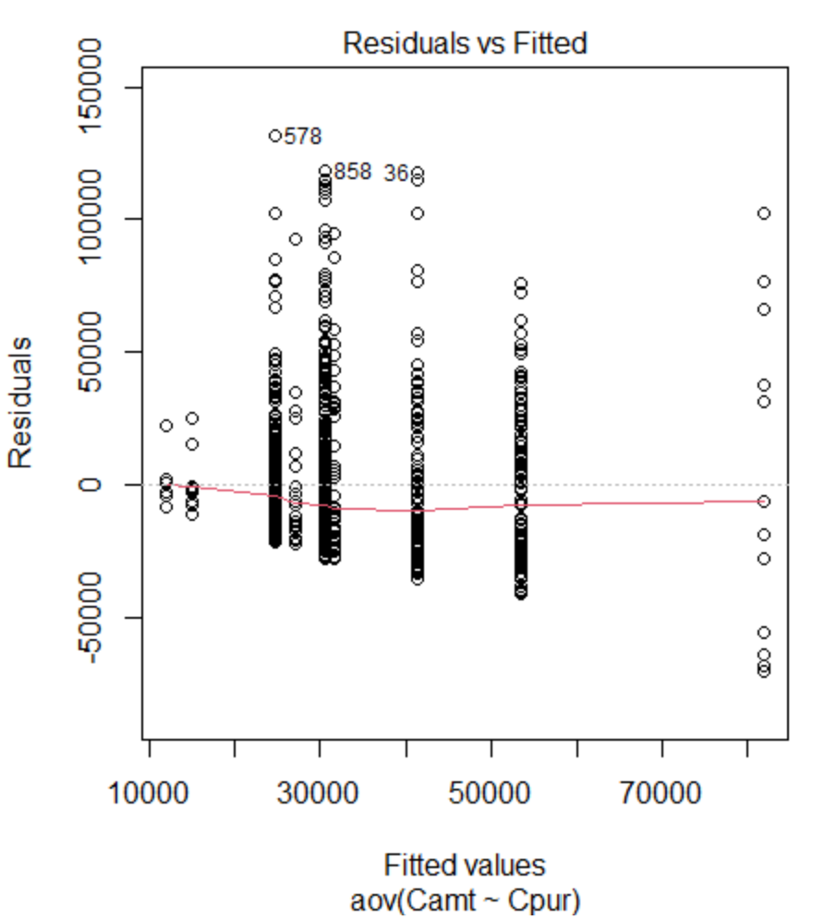

**Normality Assumption**

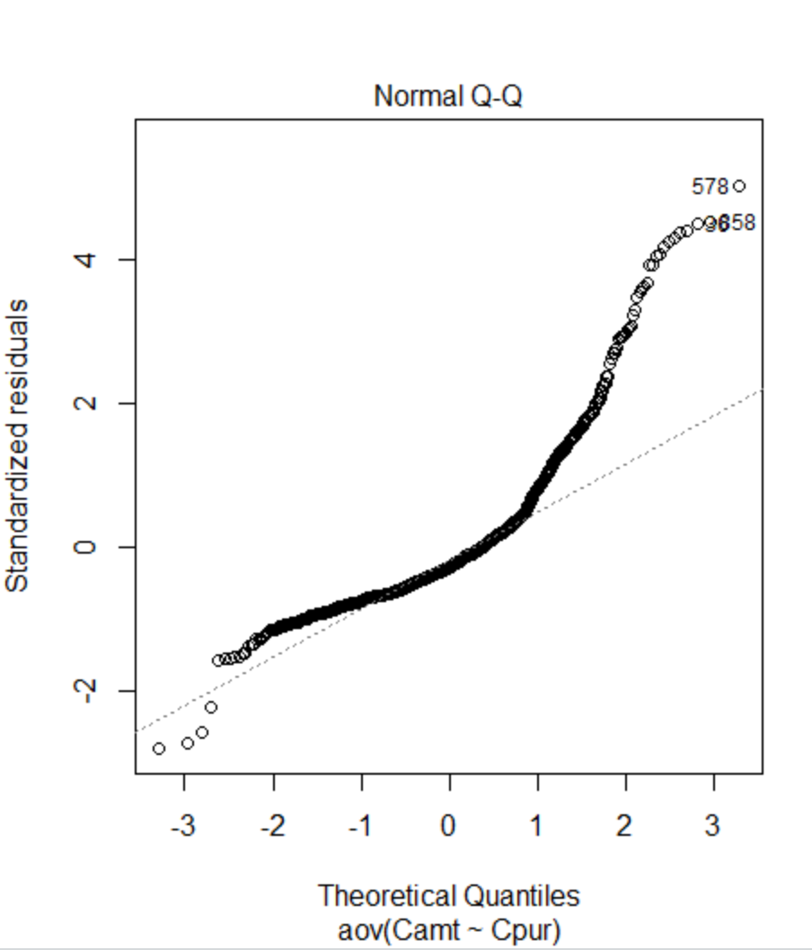

**Shapiro Wilk Test**

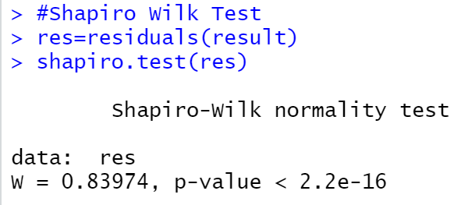

As p value is less than 0.05, it implies that there exists a significant difference from normal distribution, we can assume there exists no normality

**Kruskal Wallis Test**

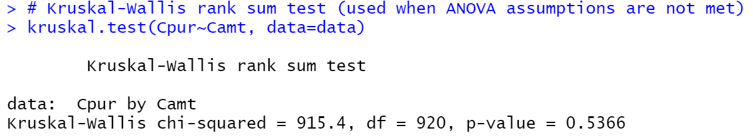

1. **Using Camt and Job Type**

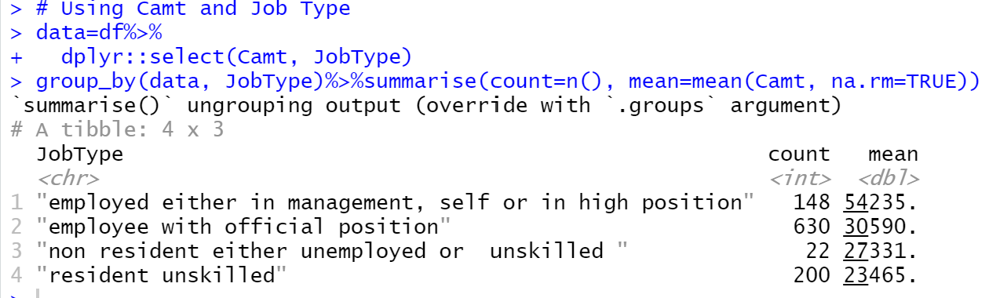

**ANOVA**

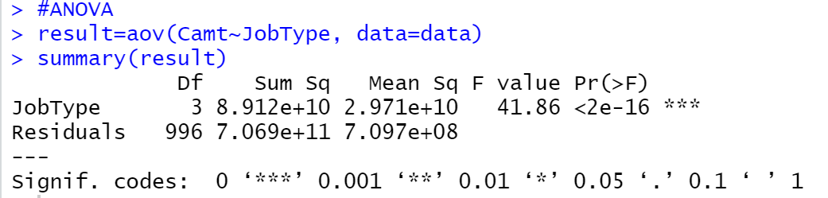

**Due to low F value, the mean of the groups is significantly different.**

**TukeyHSD**

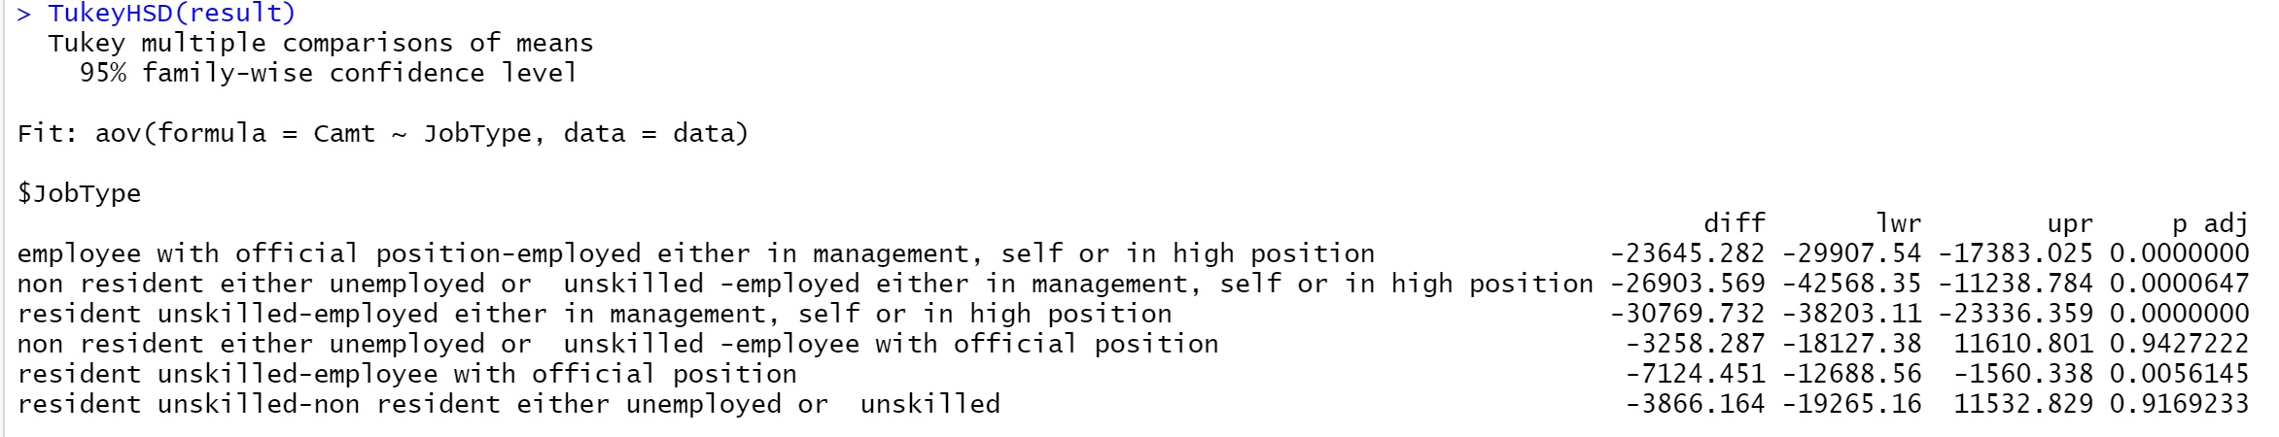

**Homogeneity of the variances**

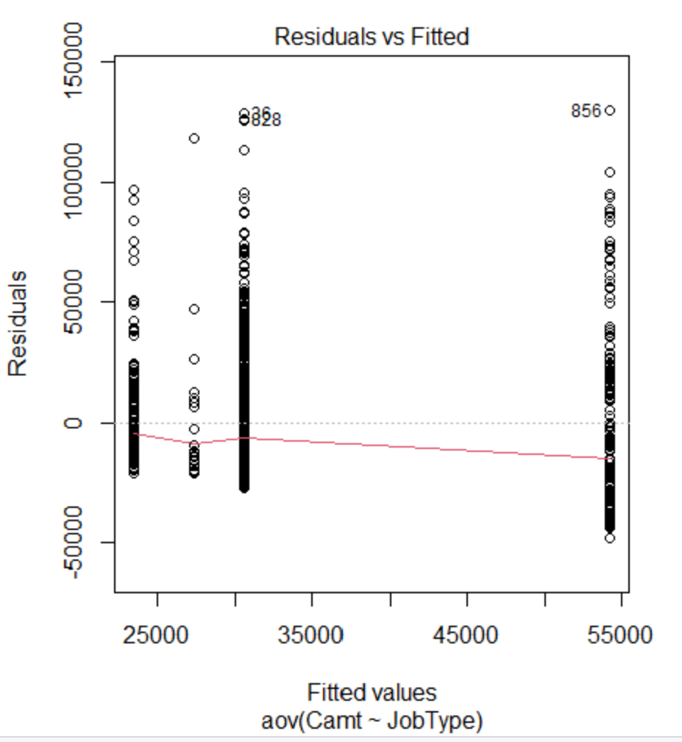

**Normality Assumption**

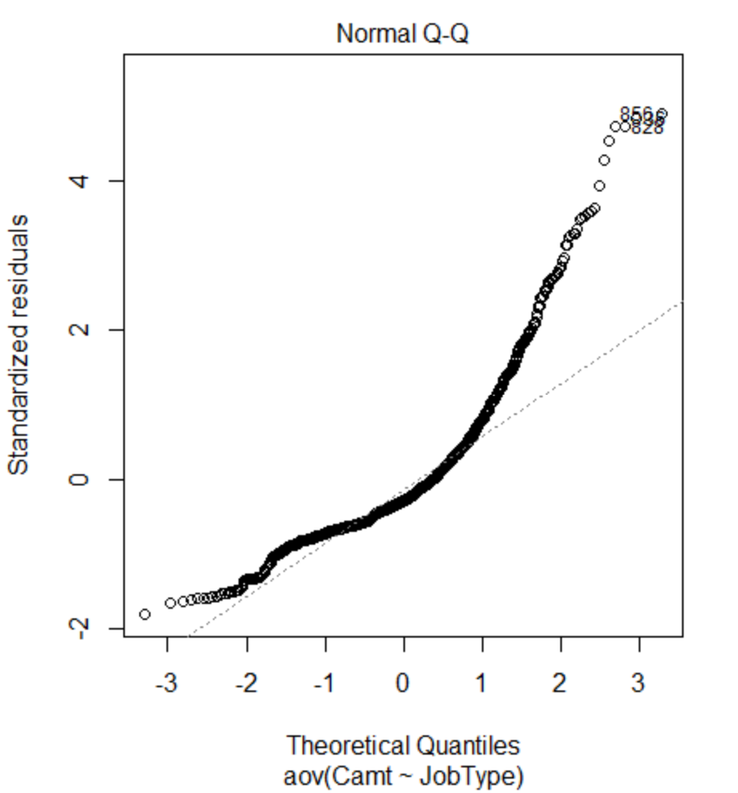

**Shapiro Wilk Test**



As p value is less than 0.05, it implies that there exists a significant difference from normal distribution, we can assume there exists no normality

**Kruskal Wallis Test**

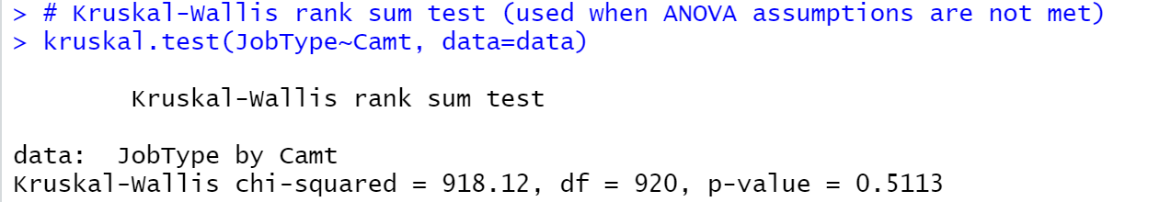

1. **Using Camt and Htype**

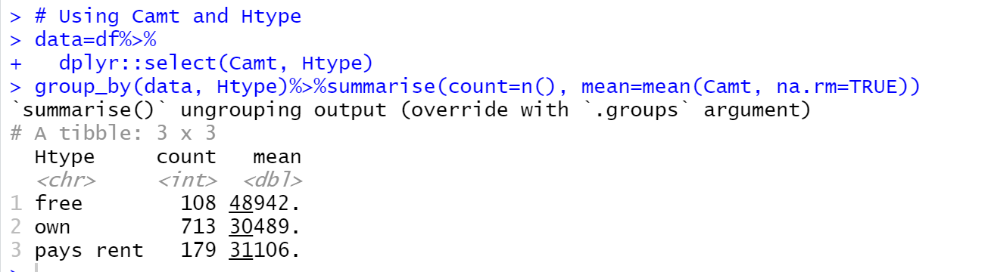

**ANOVA**

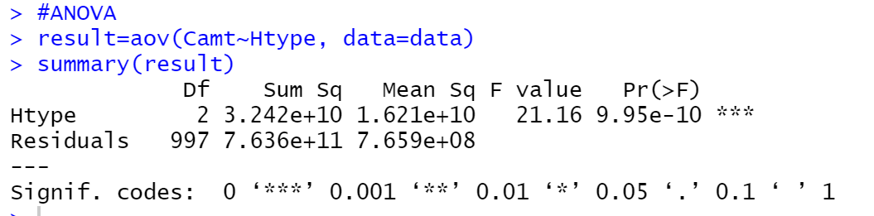

**Due to low F value, the mean of the groups is significantly different.**

**TukeyHSD Test**

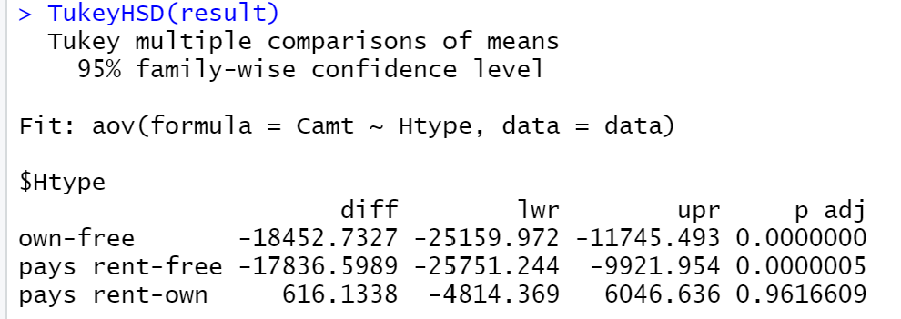

**Homogeneity of the variances**

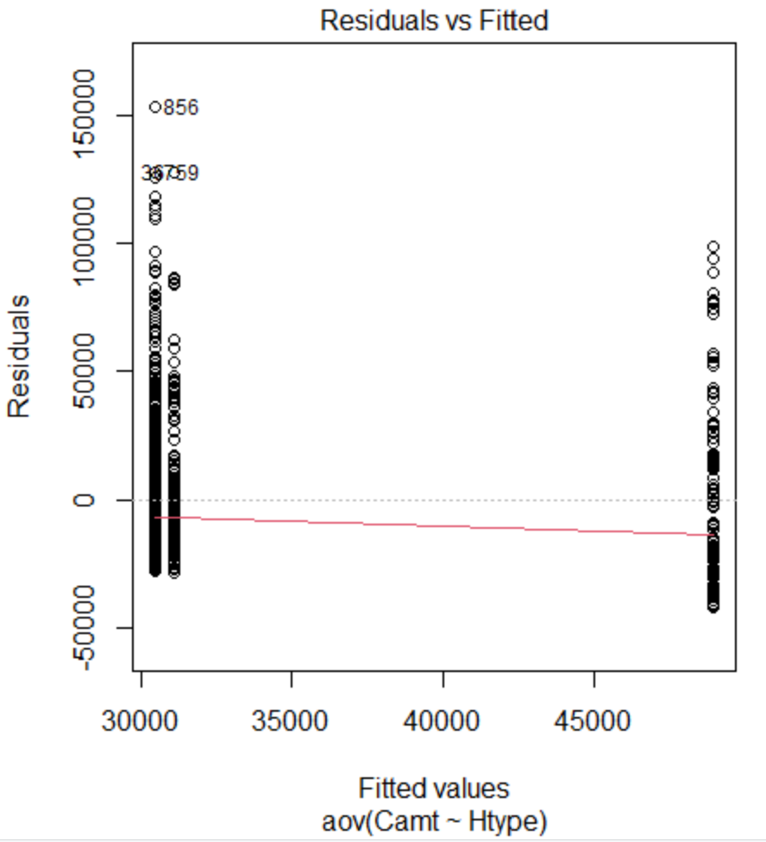

**Normality Assumption**

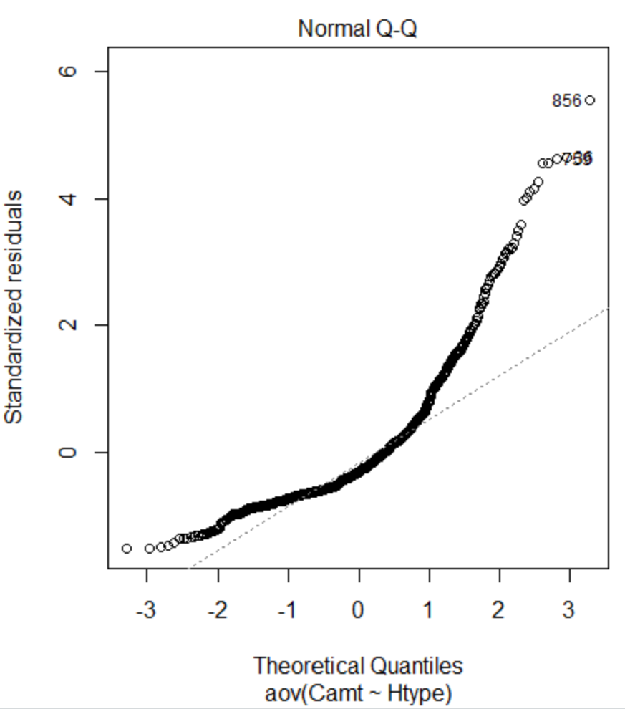

**Kruskal Wallis Test**

